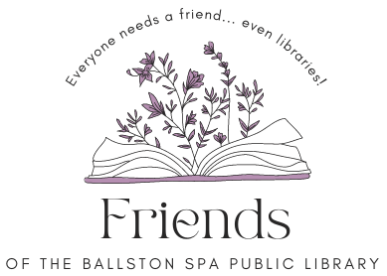
Board Meeting
Thursday April 18, 2024, 6 p.m.
Agenda
Welcome and introduction (5 minutes).
FOBSPL Programs - Trivia Night – Hannah Matacko-Conti and Lori Acee Skidmore College Library (20 minutes).
Approval of minutes – All (5 minutes).
Treasurer’s report – Meredith (10 minutes).
Update on Membership – Shelley (10 minutes)
FOBSPL Programs/Events (All 20 minutes)
- Future program ideas – Book swap, local author event,
- 2024 Ballston Spa Farmers’ Market,
- May 3 photo with Mary Beth Walsh
- Sponsorship BSBPA Movies in the Park

Member Concerns – All (10 minutes).
Approval of Invoice #6 for Butler Rowland Mays*- FOBSPL Board (10 minutes).
Approval of Hartford Insurance Business Owners Liability Renewal * – FOBSPL Board (10 minutes)
Next meeting Thurs. May 16 at 6 p.m.
Note* Items that require FOBSPL Board approval are sent to the FOBSPL Board Members in advance of the meeting.
21 Milton Ave, Ballston Spa, NY 12020. Find us on the library website https://bspl.sals.edu
(518) 885 5022

