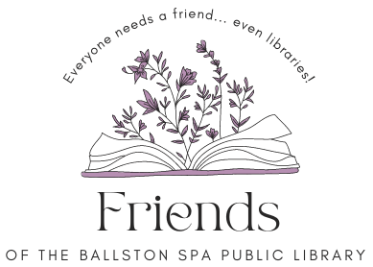
Board Meeting
Thursday May 16, 2024, 6 p.m.
Agenda
Welcome and introduction (5 minutes).
Approval of April 18, 2024, minutes – All (5 minutes).
Treasurer’s report – Meredith (10 minutes).
Capital Campaign, Butler Rowland Mays progress, grants – Lori (10 minutes)
FOBSPL Programs/Events - All
- Trivia Night Wed. June 12 at 7 p.m. with Hannah Matacko Conti – Plans, promotion, and assignments (20 minutes).
- Movies in the Park June 7, July 5, Aug. 2 – Plans and assignments (15 minutes)
- Fall Program during The Way We Were Car Show - Donation items, FOBSPL role, Books Sale, Promotion, etc. (30 minutes)

Member Concerns – All (10 minutes).
Approval of Invoice #7 ($2,550) for Butler Rowland Mays*- FOBSPL Board (10 minutes).

Next meeting Thurs. June 20 at 6 p.m.
Note* Items that require FOBSPL Board approval are sent to the FOBSPL Board Members in advance of the meeting.
21 Milton Ave, Ballston Spa, NY 12020. Find us on the library website https://bspl.sals.edu
(518) 885 5022

