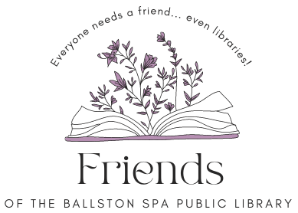
Board Meeting
Thursday July 18, 2024, 6 p.m.

Agenda
Welcome and introduction (5 minutes).
Approval of June 20, 2024, minutes – All (5 minutes).
Treasurer’s report – Meredith (10 minutes).
Moving of local history material update - All (15 minutes)
FOBSPL Programs/Events - All
- Movies in the Park Review of July 5 evening (5 minutes).
- Upcoming programs (5 minutes)

Discussion and approval of Invoice #8 from Butler Rowland Mays, Architects, LLP by FOBSPL Board of Directors. Invoice sent to BOD 7.12.24 (10 minutes).

Next meeting Thurs. Thurs. Aug. 15 at 6 p.m.

21 Milton Ave, Ballston Spa, NY 12020. Find us on the library website https://bspl.sals.edu
(518) 885 5022

