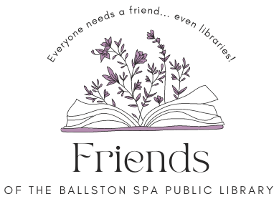

Board Meeting
Thursday, Oct. 16, 2025, 6 p.m.
Ballston Spa Public Library, 21 Milton, Ave. Ballston Spa, NY
Local History Room, Lower Level

Agenda

- Welcome and introduction (5 minutes)
- Treasurer’s report – Meredith
- Booksale and Raffle debrief - All.
- Fundraising project.
  - Book Bindery Oct. 18.
  - General Solicitation End of Year Lori/Andy
- Library Update
- Member Concerns

Next meeting Thurs., Nov. 20, 2025, at 6 p.m., Location: Ballston Spa Public Library Local History Room.
21 Milton Ave, Ballston Spa, NY 12020. Find us on the library website https://bspl.sals.edu
(518) 885 5022

